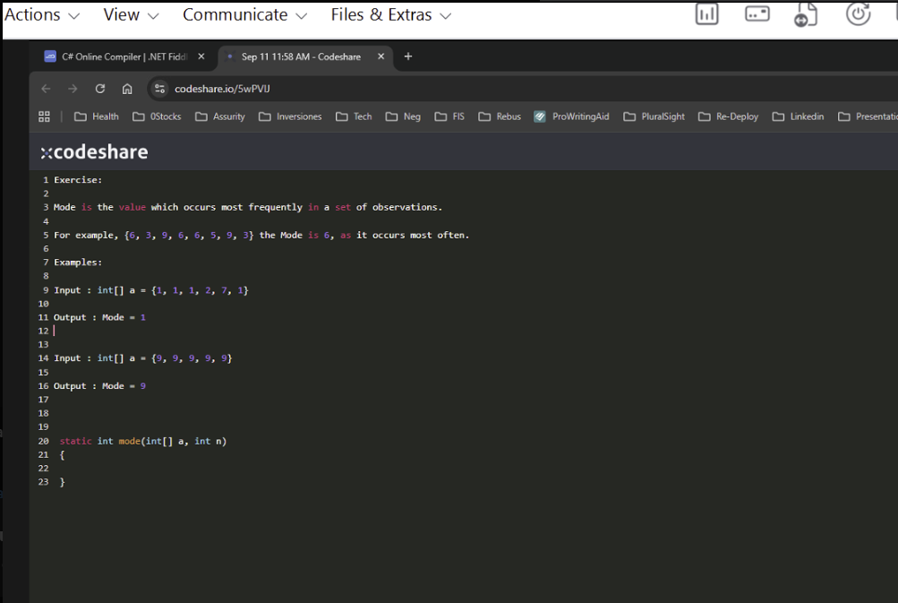
Here was the second version I could have done this
Question 1: Find the Mode in an Integer Array
- Goal: Identify the number that appears most frequently in an array.
- Your Solution:
You wrote a working brute-force method using nested loops:
static int mode(int[] a, int n)
{
int mode = a[0], maxCount = 0;

for (int i = 0; i < n; i++)
{
int count = 0;
for (int j = 0; j < n; j++)
{
if (a[j] == a[i])
count++;
}
if (count > maxCount)
{
maxCount = count;
mode = a[i];
}
}
return mode;
}

Optimized Solution Using Dictionary<int, int>
static int mode(int[] a, int n)
{
Dictionary<int, int> frequency = new Dictionary<int, int>();
int mode = a[0];
int maxCount = 0;

for (int i = 0; i < n; i++)
{
if (frequency.ContainsKey(a[i]))
frequency[a[i]]++;
else
frequency[a[i]] = 1;

if (frequency[a[i]] > maxCount)
{
maxCount = frequency[a[i]];
mode = a[i];
}
}

return mode;
}

